Creating learning resources that include third party text and artistic works

Use this flowchart if you wish to upload teaching resources that include third party text and artistic works (ie material where the copyright is not owned by your TAFE) to a password protected digital teaching environment (DTE).

Are you able to create your own version or use public domain
material, Creative Commons (CC) material or link to it instead?

YES NO

Have you got permission to use the image or can you seek permission?

Link
Linking is okay as it is not a copyright activity.
Copyright has
expired
Material in which copyright has expired is free to use.
Creative Commons
(CC)
Free to use provided you comply with licence conditions.
Create your own
version
TAFE owned material can be used however you would like, but label.

If YES, use in accordance with the permission or seek permission.

If NO, you may be able to rely on the Statutory Text and Artistic Works Licence (s 113P).

If you are not using any third party material (ie your resource only includes TAFE owned content), you can use the resource however you like. However, we recommend you license your resource under a Creative Commons (CC) licence.

Remember you must attribute all the materials you use. For more information on attribution, see Labelling and Attributing.

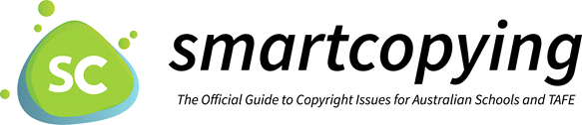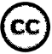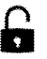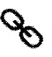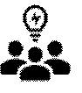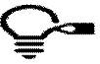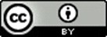

National Copyright Unit, Copyright Advisory Groups (Schools and TAFEs) smartcopying@det.nsw.edu.au

