Creating learning resources that include third party material for students with a disability

Resources created under the Disability Access Exceptions should only be uploaded to a password
protected digital teaching environment (DTE) for the students with the relevant disability.

Is the material commercially available in the accessible format I need?
‘Disability’ is defined broadly. It includes difficulty in reading, viewing, hearing or comprehending copyright material in a particular form.

YES NO

Do I need all or just a small portion of the
material?
You can copy or format shift the entire work under the
organisational disability exception (s 113F) but label.

You can also copy or format shift an extract or portion of the material for students with a disability under fair dealing for disability exception (s 113E) but label.

If all, purchase the accessible format
material and use it in your resource.

You can copy an extract or portion of the material for students with a disability under fair dealing for disability exception (s 113E) but label.

Label the material with:
‘This material has been copied/made available to you under section 113E/113F [delete as appropriate] of the Copyright Act. Any further reproduction or communication of this material by you may be the subject of copyright protection under the Act. Do not remove this notice.’

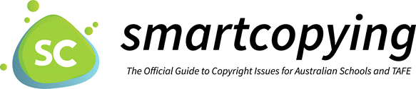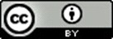

National Copyright Unit, Copyright Advisory Groups (Schools and TAFEs) smartcopying@det.nsw.edu.au

