Creating learning resources that include third party text and artistic works – Education Department or Education Body
Use this flowchart if you wish to upload teaching resources that include third party text and artistic works (ie material where the copyright is not owned by the Education Department or Education Body) to a public website or password protected intranet.

Are you able to link to the material, use Creative Commons (CC) material, use material in which copyright has expired or create your own material instead?

YES NO

Have you got permission to use the image/
text or can you seek permission?

Link
Linking is okay as it is not a copyright activity.
Creative Commons (CC)
Free to use provided you comply with licence conditions.
Copyright has expired
Work in which copyright has expired is free to use.
Create your own version Education Department/ Education Body owned material can be used however you would like, but label.

If yes, upload to either a public website or password protected intranet, depending on the permission.

If no, you may be able to rely on the Statutory Text and Artistic Works Licence (s 113P).

If you are not using any third party material, you can upload the

Restrict access to resource via a password protected intranet.
If the permission allows you to, upload the resource to a public facing website.
resource to a public facing website.

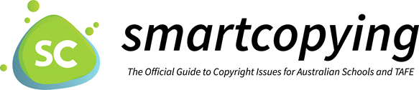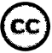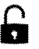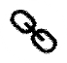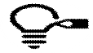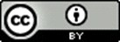
National Copyright Unit, Copyright Advisory Groups (Schools and TAFEs) smartcopying@det.nsw.edu.au
Remember you must attribute all the materials you use. For more information on attribution, see Labelling and Attributing.

