iTunes U – Schools and Teachers

This information sheet deals with schools and teachers using iTunes U for educational purposes. It is intended to provide guidance on the following:

- best practice when using content from iTunes U
- the rules that you need to be aware of to ensure that you comply with copyright when using content from iTunes U and
- setting up courses or class areas using iTunes U.

What is iTunes U?

iTunes U is a dedicated section of Apple’s iTunes Store that contains a wide variety of print and audiovisual educational content (eg student worksheets, quizzes, PowerPoints, lecture notes, readings, lesson plans, presentations, PowerPoints, lab demos, video lectures, webcasts, podcasts etc) from universities, museums and public media organisations available to download or to access from cloud storage. iTunes U allows a user to search for, download and play educational content in the same way that they can search, download and play songs, podcasts, television shows and movies from iTunes.

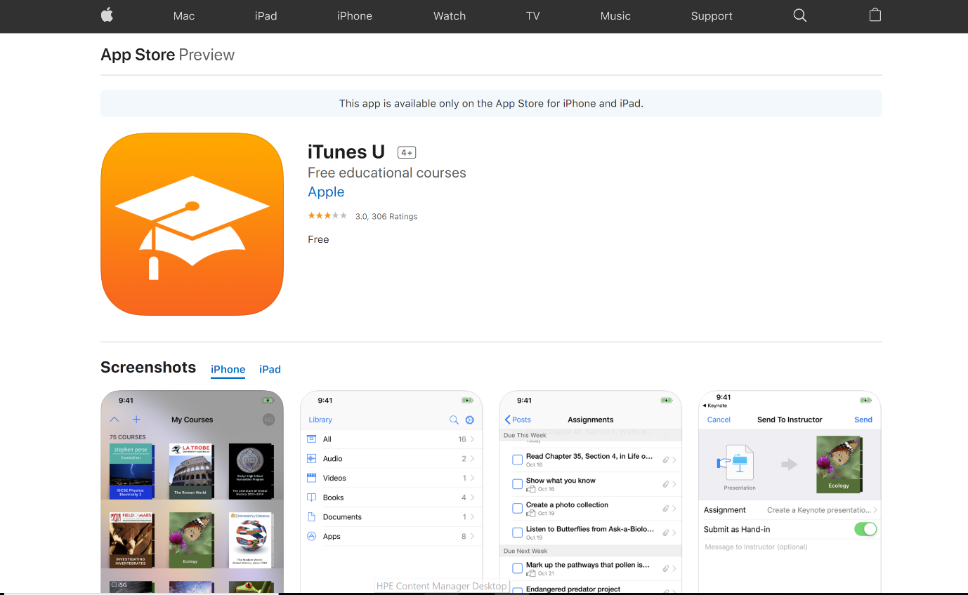

To use the service, a user is required to download and install iTunes on an Internet-connected computer, iPad, tablet or mobile phone, and then download the iTunes U app

from the iTunes Store (shown in the screenshot above). Users can select entire courses or choose individual video, audio recordings, ebooks or PDFs etc. Selected material can be found in the ‘My iTunes U’ section on each user’s iTunes. The material can then either be watched directly on the PC or synchronised onto a portable media player for mobile learning.
Teachers can also use iTunes U to make their own content available to students.

Best practice when using iTunes U content

The NCU encourages teachers – wherever possible – to engage in “smartcopying” practices that help manage copyright costs.

Using Creative Commons licensed content and Open Education Resources
NCU encourages teachers to use Creative Commons (CC) licensed content, and Open Education Resources, also known as “OER” wherever possible. This not only helps save money on the national copyright fees, it’s also much safer for teachers, as they are free to reuse, remix, redistribute and adapt education resources without running the risk of breaching the complex copyright exceptions and copyright licence rules which are discussed in section 3 below.

For more information CC and OER content, see the following links:
OER, and Creative Commons Quick Reference and CC Guide for Educators.

Currently, iTunes U does not have search functionality that lets you search for CC licensed material, however universities such as Oxford, Yale, Stanford and MIT have made materials available as CC-licensed offerings. These materials are easy to identify if they bear the CC logo as seen in the following screenshot:
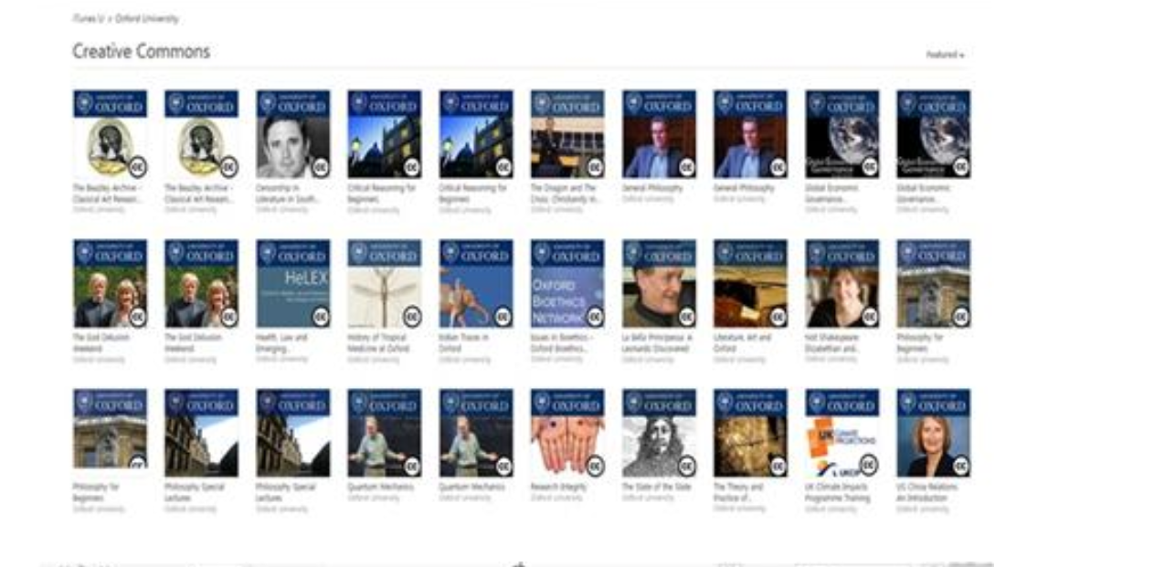
There might also be licence information displayed on the iTunes U page which confirms that it is CC licensed as seen in the following screenshot:
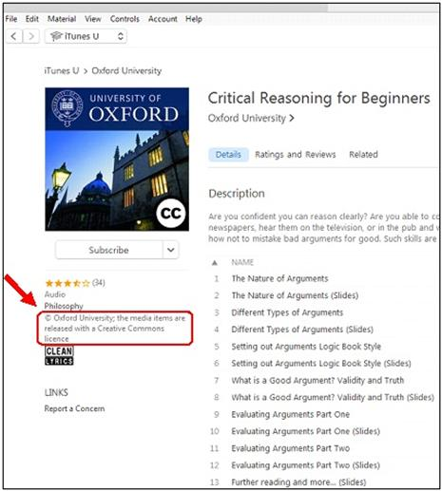

Linking wherever possible
Wherever possible, provide students with links to content on iTunes U rather than uploading the content onto a school shared drive, intranet, learning management system etc. This is because linking to the content does not attract a copyright payment. You can use the ‘Copy the link’ option from the dropdown menu next to the ‘Get’ icon.
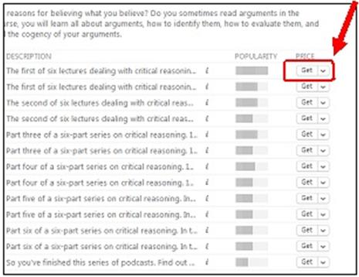

Getting students to download content to their own devices, iCloud storage etc
Another Smartcopying option is to get students to download/save etc the content to their own device or iCloud storage as an alternative to the teacher uploading the content onto a school drive, intranet or learning management system. Copying iTunes U material to a password protected school’s share drive, intranet, cloud storage or learning management system may attract remuneration under the Statutory Text and Artistic Works Licence, whereas students downloading or saving material to their personal device or iCloud storage does not.

Attributing the source
All material created and used for educational purposes should be properly attributed. Attributing is important to ensure that schools don’t pay licence fees for material you already own or are allowed to use (eg teacher/school/student created content).
Attribution information needs to include details of the copyright owner and/or author, where the material was sourced from and when.

See the Smartcopying’s labelling information sheet Labelling and Attributing.

Deleting or archiving material when it is no longer needed
Clearing out material on a DTE that is no longer required is one practical way of managing your compliance with the Statutory Text and Artistic Works Licence and the Statutory Broadcast Licence.

This can be done in two ways:

- deleting material

Material that the school no longer requires for educational purposes should be completely deleted. This will assist in minimising the storage burden on the school as well as ensuring that the school is not incurring copyright fees for material it no longer needs.

- archiving material

Material should be archived where the school expects to use the material again for educational purposes in the future.

Archiving involves moving the material into a closed area online where it can only be accessed by one person, such as the school librarian, ICT Manager or teacher who uploaded the material in the first place. Restricting access to the material will ensure that the school is not incurring additional copyright fees.

The Copyright rules that you need to be aware of when using iTunes U

When you use content from iTunes U for educational purposes you will generally be engaging in two activities (even though it might seem like only one activity):

- Making a copy of the content. This includes downloading the content from iTunes U onto a PC, shared drive, USB, hard drive, cloud storage, smartphones, tablets etc.
- Communicating the content. This includes uploading or saving a copy to a device from which it can be accessed by students; eg share drive/intranet (Microsoft 365), content or learning management systems (Moodle, Blackboard, Brightspace or Equella), closed class area on an education platform (Edmodo, Verso, Google Classroom or iTunesU), cloud storage etc.

If the content that you are using is not CC licensed or OER, you need to comply with the following copyright rules.

Different rules apply depending on whether the content that you are using is text or graphic content (eg documents, readings, worksheets, quizzes, PowerPoints, assignments, images, illustrations, charts etc) or audio-visual content (eg sound clips, film clips, videos, webinars, podcasts etc):

- The rules that apply to use of text and graphic content
Copying and communication of text and graphic content is covered by the Statutory Text and Artistic Works Licence. Text and graphic content includes works.

How much can be used?
If the content is available to be accessed without payment; ie free (as the vast amount of iTunes U content is), you can use the whole document; ie there is no restriction on the amount that you can copy or communicate.

If the content is only available for purchase you will need to comply with the copying and communication limits that apply under the Statutory Text and Artistic Works Licence; ie
- 10% or 1 chapter of a book (whichever is greater)
- 10% of words on a website or
- one article in a journal, more than one if on the same subject matter (including articles from online publications such as e-journals, e-books or e-newspapers).

Restricting access to the content
Access to material copied and communicated under the Statutory Text and Artistic Works Licence must be restricted (eg by use of a password) to teachers and students. You must ensure that the material is not able to be accessed by the general public. It is, however, permissible to allow parents to have access to enable them to assist students with homework etc.

Labelling and notice requirements
Material copied under the Statutory Text and Artistic Works Licence must be labelled with the name of the copyright owner and author (if different to the copyright owner), where the material was copied from and when it was copied. See example below.

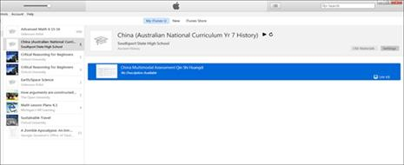

eg: Copied under Section 113P of the Copyright Act 1968

Southport State High School, China Multimodal Assessment Qin Shi Huangdi, accessed 19 September 2020.

It is also best practice to include the following notice:
[WARNING]
This material has been copied [and communicated to you] in accordance with the statutory licence in section 113P of the Copyright Act. Any further reproduction or communication of this material by you may be the subject of copyright protection under the Act. Do not remove this notice.

As attaching the notice in full is not always practical or feasible, NCU recommends that teachers simply provide a link to the notice as part of the labelling requirement eg:
Copied under the statutory licence in s 113P of the Copyright Act
Southport State High School, China Multimodal Assessment Qin Shi Huangdi, accessed 19 September 2020
S 113P Notice: [insert link to notice]

The rules that apply to use of audio-visual content

Different rules apply to the use of audio-visual content such as video lectures, webinars, podcasts etc that is not CC licensed or OER.
In limited circumstances, schools and teachers may copy or communicate audio-visual content under the flexible dealing exception in section 200AB. In order to determine whether s 200AB will apply to your intended use you should consult the following information sheet, Flexible Dealing.

Labelling copies
It is good practice to label copies made under the flexible dealing exception with words similar to: “Copied under section 200AB of the Copyright Act 1968”.

It is also good practice to include the name of the online video, URL address of its location and the date it was copied:
Copied under s 200AB of the Copyright Act 1968
‘What Anzac Means To Me’,
https://itunes.apple.com/au/course/what-anzac-means-to-me/id960120027?i=1000342828606&mt=2, 27 September 2020

Restricting access to the content
Access to material copied and communicated under the flexible dealing exception must be restricted (eg by use of a password) to teachers and students. You must ensure that the material is not able to be accessed by the general public. It is, however, permissible to allow parents to have access to enable them to assist students with homework etc.

Setting up class courses or class areas on iTunes U

Teachers can use iTunes U to manage their lessons, teaching resources and class/student assignments via the “Create a course” option. After a course has been created the teacher can add lesson plans, posts, assignments and materials to the course. Assignments and materials can consist of documents, photos, videos, audio files and weblinks.

For more information on how set up class courses or class areas see https://www.apple.com/support/itunes-u/course-manager/.

If you have included any content that has been copied under the Statutory Text and Artistic Works Licence, or the flexible dealing exception in s 200AB, you must ensure that access to the content is restricted to staff and students (and their parents) as discussed in section 3 above.

If the material that you have uploaded contains only your own original material (ie content created by you or the school), and/or CC licensed or OER content, there is no prohibition on allowing the general public to have access to the content.

NCU encourages teachers who have uploaded their own original content to iTunes U to attach a CC Attribution 4.0 International Licence to the content permitting others to use it. This is the least restrictive CC licence. If you want to use a more restrictive or different CC, contact the NCU to discuss. For more information see Creative Commons Information Pack for Teachers and Students and Applying a Creative Commons Licences to your teaching material on iTunes U.

