Where to Find OER Materials

There is an abundance of OER materials open for everyone to use and available on the Internet. However, the key is knowing where to find such materials. Once you master this, it is surprisingly easy to find quality materials. OER goes hand in hand with CC licensed materials; links to good sources of CC licensed materials can be found at: Where to find CC licensed materials.

Our top 6 OER repositories are as follows:

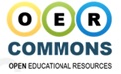OER Commons offers over 160,000 OER easily searchable by refinable topics including subject areas, education levels, material type and media formats for all levels of education.

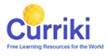Curriki offers more than 60,000 curated OER easily searchable by refinable topics including subject areas, education levels, material type, languages and review ratings for all levels of education.

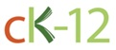CK-12 offers free high-quality, standards-aligned, open content in primary and high school level maths, science, technology, engineering and many more subjects. It also offers interactive apps for smartphones and computers.

Connexions offers tens of thousands of learning objects, called pages, that are organised into thousands of textbook-style books in a host of disciplines, searchable by author, title, subject areas, language, publication date and popularity.

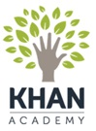The Khan Academy contains a diverse library of practice exercises and instructional videos translated into almost 40 languages which cover math, biology, chemistry, physics, the humanities, finance and history. The Khan Academy also offers tools to monitor class performance and individual student profiles.

Other good OER resources:

LeMill is a web community for sharing OER with over 70,000 resources in different languages.

Open Knowledge Repository has over 18,000 open research publications funded by the World Bank.

Directory of Open Access Journals offer over 1.8 million open access peer-reviewed articles searchable by subject, language, origin and year of publication.

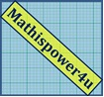Mathispower4u Tutorials offers over 4,000 open mini-lessons and video examples on mathematics with a companion YouTube channel.

Open Textbooks

There are sources of open textbooks on a variety of subjects:

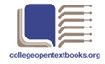College Open Textbooks is a collection of textbooks covering a wide range of higher education subjects.

OpenStax College offers open textbooks covering a range of higher education courses.

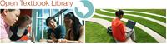Open Textbook Library. Open textbooks are textbooks that have been funded, published, and licensed to be freely used, adapted, and distributed. These books have been reviewed by faculty from a variety of colleges and universities to assess their quality. These books can be downloaded for no cost, or printed at low cost. All textbooks are either used at multiple higher education institutions, or affiliated with an institution, scholarly society, or professional organisation.

Interactive simulations

If you are looking for interactive resources the following offers interactive simulations which are particularly helpful in the areas of science and maths:

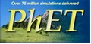PhET provides fun, free, interactive, research-based science and mathematics simulations.

Complete courses

Whilst these may be aimed at higher education, there are sources of modular course components and complete courses which may also be of interest for teachers who are looking at specific subjects:

Jorum is UK’s largest OER repository, offering thousands of OER on a wide variety of subjects.

Open Learn offers over 600 free and open courses and is a part of the UK Open University.

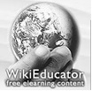Wikieducator offers information and pages from this online open education community.

Wikiversity offers thousands of OER for use in all levels, types, and styles of education from pre-school to university, including professional training and informal learning.

MIT OpenCourseWare (OCW) is a web-based publication of virtually all MIT course content with translations into several languages.
P2PU is an online community of open courses, browsable by schools, tags and what’s featured.

OER in Australia

OER is a global phenomenon and whilst it is currently concentrated in a few countries, there are a growing number of good OER websites in Australia:

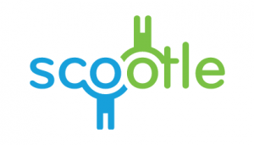Scootle has over 1500 learning resources made available under CC licenses by Education Services Australia.

Please see below three other national subject aligned sites that are open CC portals:

Digital Technologies Hub (CC BY)

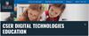 CSER Digital Technologies MOOC

Student Wellbeing Hub

The Australian Curriculum and Assessment Authority (ACARA) offers the Australian curriculum as an OER.

The University of Southern Queensland’s OpenCourseWare (USQ OCW) provides OER and sample courses from 5 faculties including science and technology.

First Steps is a WA Department of Education website which offers OER on literacy, maths and physical education.
Charles Darwin University offers a digital repository of endangered literature in Australian Indigenous languages from around the Northern Territory as OER.

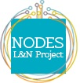Nodes is a joint Northern Territory Department of Education and Commonwealth Government website which offers extracts of literacy and numeracy proficiencies from Hospitality and Tourism Certificates I and II as OER and compatible quizzes.

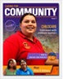PreVET is a joint Northern Territory Department of Education and Commonwealth Government website which offers OER covering 18 topics aimed at showcasing Indigenous role models and relevant employment pathways for remote job seekers. The topics are laid out in creative and communicative magazine formats and videos that introduce positive ideas around work culture and resilience with work.

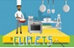 Fliplets is a joint Northern Territory Department of Education and Commonwealth Government website which offers Certificate I Hospitality OER through a contextualised eLearning package especially useful for remote educators or students.

A New Kind of Alchemy is an interactive online graphic novel about a future world threatened by extinction. It is based on a short story by Australian writer, James Roy. The graphics can be downloaded and used to create your own story.

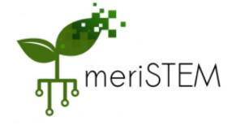meriSTEM (modular educational resources in Science, Technology, Engineering and Mathematics) is an free offering to schools. meriSTEM leverages the enthusiasm of expert scientists from The Australian National University to provide teachers with pre-made flipped classroom resources for senior secondary STEM subjects. At the moment they offer senior physics, chemistry and biology and other STEM subjects are in the pipeline.

