How to find Creative Commons materials using the Creative Commons Search Portal

To make finding Creative Commons material as easy as possible, Creative Commons hosts a CC Search Portal on its website (www.creativecommons.org). Using the metadata that is part of all CC licences, the search portal can return results based on search terms and the type of use you want to make from a number of websites. This guide was created to help teachers, students and curriculum units find CC licensed material using the CC Search Portal. It forms one part of an information pack on CC for the education sector. It is advised that you first read information guide ‘What is Creative Commons?’ for a simple and helpful introduction to CC.

The Creative Commons Search Portal is not the only way to search for CC material. You can also use Google or go directly to sites that have the type of CC material you’re looking for.

For information on how to use google see ‘How to find Creative Commons Material using Google’

For a list of sites that host CC material see: this wiki on Content Directories and Smartcopying’s list of OER.

Finding CC materials using the Creative Commons Search Portal

Below is a step-by-step guide to using the search tools in CC Search Portal to find content released under Creative Commons licences. The CC Search Portal allows users to return very specific results from a number of sources. By reading the metadata embedded in the digital files of content licensed under Creative Commons, the search portal can find content that is available for certain kinds of uses, including works that are available for commercial reuse and works that are available for remixing. By limiting the search to specific sites that only include one type of content (eg videos, photos or music), the CC Search portal also lets you search for specific types of material. This can give it an advantage over the CC search tools provided by Google.

It is important to consider how you want to use any CC material before you begin your search. This is because different CC licences let you do different things. Knowing what you want to do with the material will help you choose the licence that is suitable for your use.

Step 1. Start a CC Search

There are two ways to get to the Creative Commons Search Portal. You can access it directly by typing http://search.creativecommons.org into the address bar on your web browser. Alternatively, you can get to it by clicking on “Search the Commons” at the top of the page.

Step 2. Choose the right licence for what you want to do

To filter material based on the type of use you want to make, go to the box at the top right hand side of the search query field. This gives you two options ‘I want something that I can use for commercial purposes’ and ‘I want something that I can modify, adapt or build upon’. Both options are automatically selected, however you should adjust these selections to reflect the option(s) appropriate for your use. You can select one, both or none of the boxes.
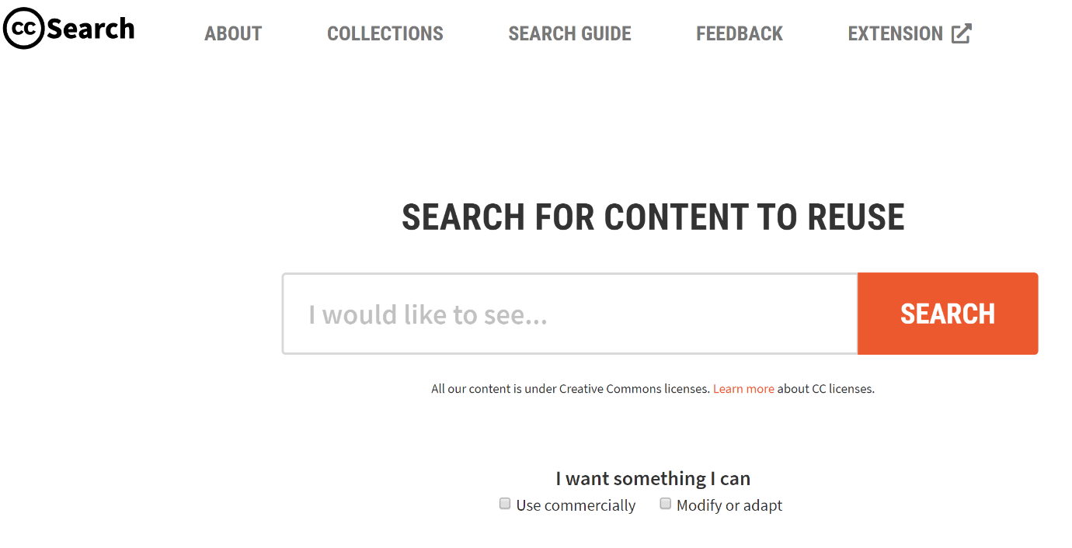
For example, if you select ‘use for commercial purposes’, the search engine will exclude content under a licence which prohibits commercial use (ie that includes the Non-commercial term). Similarly, selecting ‘modify, adapt, or build upon’ will exclude results that you cannot change (ie under a No Derivative Works licence).

If you select both options, only results under the broadest CC licences, Attribution and the Attribution-Share Alike, will be returned. If you don’t select either of the boxes, you will get material under all of the CC licences.

The table below shows how each option will filter the material by licence:

 |  | Filtering options
 |  | Neither | Use for commercial purposes | Work I can modify, adapt or build upon | Both
Results by licence | BY | yes | yes | yes | yes
 | BY-NC | yes | no | yes | no
 | BY-ND | yes | yes | no | no
 | BY-SA | yes | yes | yes | yes
 | BY-NC-SA | yes | no | yes | no
 | BY-NC-ND | yes | no | no | no

Step 3. Running the search

Now that you’ve chosen the type of licence, you can enter keywords for your refined search in the search query field and hit ‘Search’. Your results will appear on a results page.
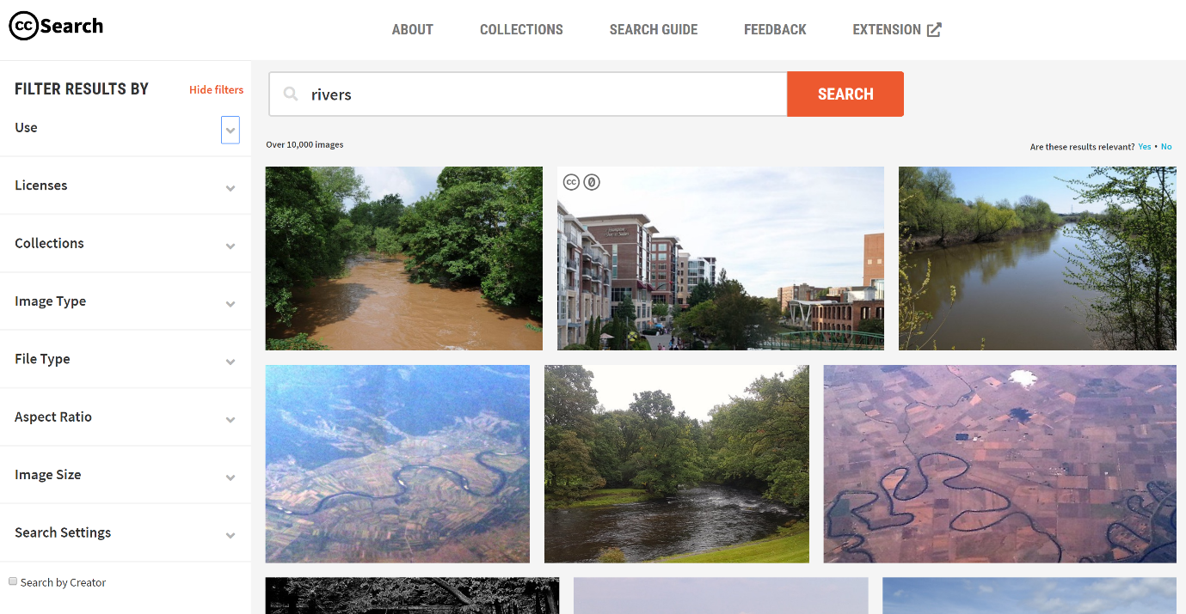

Step 4. Filtering your results

On the results page from your search you are able to further filter your results. On the left-had side of the results page there are various drop down menus where you can filter your results for:
- Use
- Licences
- Collections
- Image Type
- File Type
- Aspect Ratio
- Image Size
- Search Settings

Example
You are running a class project on river systems. The students are required to create a video on a river system of their choosing. In order to assist the students with this task, you are preparing a course pack that includes sample images for the students to use.
You want to conduct a search for CC images to include in the course pack. To do this you need to:
1. Go to the Creative Commons Search Portal.

2. As the project is designed for classroom use, there is no need to exclude non-commercial content. However, it is likely that the students will want to adapt the images so you need to limit your search for works that can be adapted or modified.

3. Enter ‘rivers’ into the into the Creative Commons Search Portal query field.
Your search returns a number of photos that are exactly the kind of images you were looking for. You insert them into your course pack, along with the appropriate attribution details. For information on how to attribute CC material, see information guide ‘How to Attribute Creative Commons Material’.

