How to attribute Creative Commons licensed materials

All Creative Commons licences require that users of the work attribute the creator. This is also a requirement under Australian copyright law. This means you always have to acknowledge the creator of the CC work you are using, as well as provide any relevant copyright information.

For many users of CC material, attribution is one of the hardest parts of the process. This information guide is designed to help you ensure you are attributing the creator of a CC licensed work in the best possible way.

What to include when attributing a work

‘Common-sense’ principles apply to providing attribution across all CC licences. When attributing a work under a CC licence you should:

- credit the creator
- provide the title of the work
- provide the URL where the work is hosted
- indicate the type of licence it is available under and provide a link to the licence (so others can find out the licence terms)
- keep intact any copyright notice associated with the work.

Another way to remember this when attributing is through TASL:

- T: Title
- A: Author
- S: Source
- L: Licence

It is important to always check whether the creator has specified a particular attribution.

This may sound like a lot of information, but there is flexibility in the way you present it. With a bit of clever formatting and linking, it is easy to include everything, particularly in the digital environment.

Of course, you do not have to include any information you cannot locate. However, you should make a good effort to find the relevant information for the material you are planning on using. Think about what you would want if it was your material that others were using.

Identifying the creator

Sometimes it can be hard to identify the person who created the material you are using. Use common sense when determining who to attribute.

If you’re on a blog or news website with a number of authors, attribute the person associated with the content you are reusing. Try to find a by-line (eg by Joan Citizen) or the name of the person it was submitted by. If there is more than one author of the content, you should attribute them all. It is a good practice in cases such as this to attribute the publication as well.

Other times, it may be difficult to find the name of the creator. This is often the case for websites like Flickr or YouTube, where the author may only be identified by their username. It is always a good idea to see if you can find their legal name, for example in the ‘about’ or ‘biography’ section of a website, on a profile page, or in the copyright notice (eg © Joan Citizen 2009). While looking to find the creator’s legal name, you should also check whether the creator has asked to be attributed in a particular way. If you can’t find the legal name, use the pseudonym or username if there is one.

Example

You want to use this photograph that you found by searching Flickr for ‘aquariums’. The photo is under a Creative Commons Attribution 2.0 licence and is posted by user ‘Qole Pejorian’.
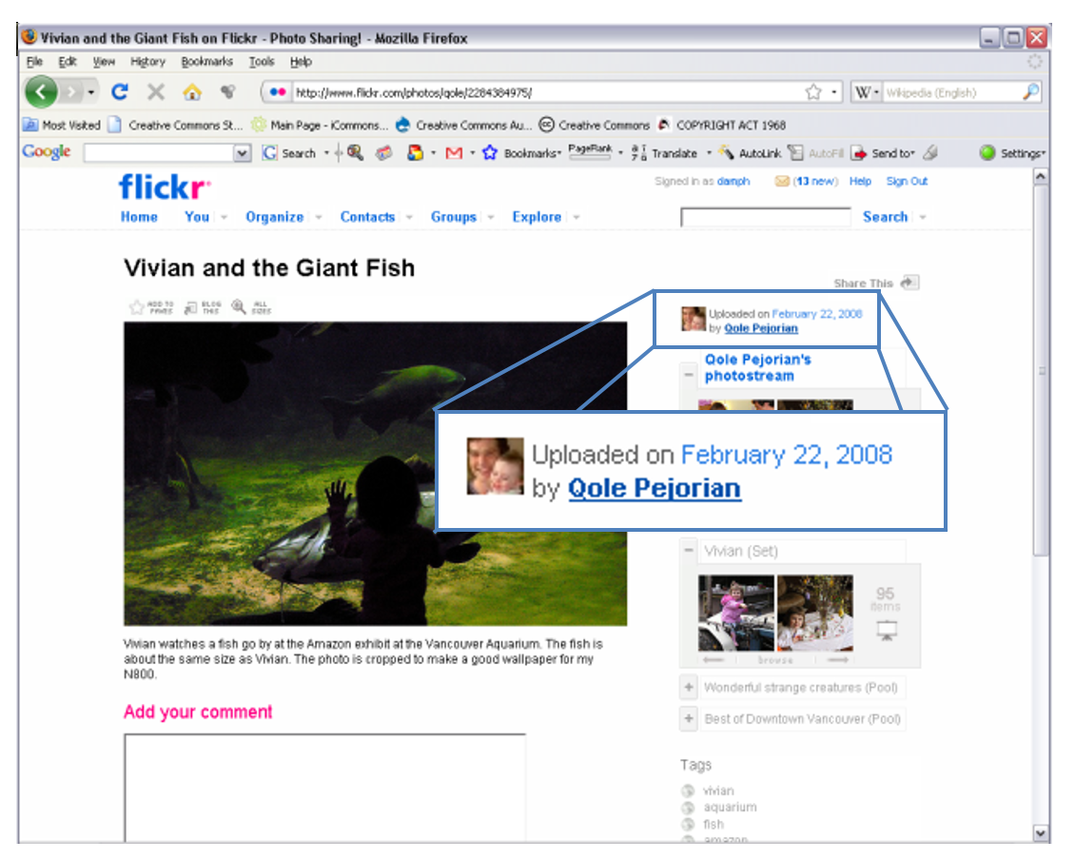

You aren’t sure whether Qole Pejorian is the user’s real name, so you click on the profile name (ie ‘Qole Pejorian’) in the right-hand column which takes you to the user’s photostream. From here, you access Qole Pejorian’s user profile by clicking on ‘Profile’ at the top of the photostream page.

On Qole Perjorian’s profile page there is a statement which tells you that the photographer’s real name is Alan Bruce. It also includes information on how he wishes to be attributed.

I have made all my photos “Attribution Only”. This licence says that you need to attribute my photos “in the manner specified by the author”. So this is the manner I wish you to attribute the photo to me: Use my real name (Alan Bruce), link back to my photo page, and please leave a comment on the photo page for any photos that you use for your own purposes.

Following these instructions, you use the following attribution for the photograph, and leave a message on the photo page telling him about your use.
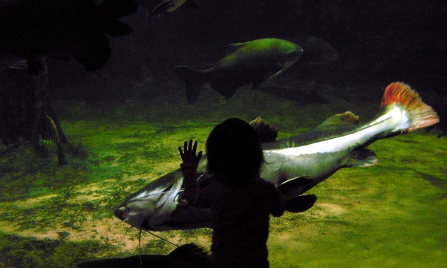

Vivian and the Giant Fish by Alan Bruce, available under a Creative Commons
Attribution Licence 2.0 at www.flickr.com/photos/qole/2284384975

Attributing others

The creator of the work may also require other parties to be included in the attribution, such as co-creators, sponsors or publishers. Where other parties are identified you should also include them in the attribution. If you are unable to provide details of all the parties, be sure to provide details of where you found the work (eg the website, magazine, journal).

Always include the CC licence

Even though it can sometimes be difficult to provide all the information, you must always include the details of the CC licence that the work is available under. This is so other people know that you have permission to use the work, that they can use it as well and under what conditions.

As you can see from the example above, the CC licences can be identified in several ways. You can list the licence name in full, use the abbreviated form of the licence or
use either the normal or compact licence buttons.

This table shows the full licence name, abbreviated form and both licence buttons for each of the six standard CC licences.

Licence | Abbreviation | Licence buttons
Attribution | BY
Attribution-ShareAlike | BY-SA
Attribution-No Derivative Works | BY-ND
Attribution-Noncommercial | BY-NC
Attribution-Noncommercial-ShareAlike | BY-NC-SA
Attribution-Noncommercial-No Derivative Works | BY-NC-ND

Link to the site

As you can see from the above examples, it is also important that, where possible, you provide a link to the site where you obtained the original work. This gives other people the ability to easily access the original work themselves. Depending on the medium in which you are reusing the work, this can be done by either using a hyperlink or the URL as text. If the original work does not have an associated URL, you do not have to link back to the original work.

Remixing the original work

If you change the original work in any way, such as cropping the work, changing the colours or replacing words, you will be creating a derivative work of the original. You should always attribute the original work in any derivative work and identify that changes have been made to it. Often the simplest way to do this is to use the phrase “This work is a derivative of…” and attribute the original work as you would normally. If your work incorporates a number of derivative works, you might say, “This work includes material from the following sources…” and list each original work. It is a good idea to state the order you are listing them in eg “This work includes material from the following sources (listed sequentially)…”

It is important to remember that if you are using material under any of the licences that include the No Derivative Works element (ie Attribution-No Derivative Works, Attribution-Noncommercial-No Derivative Works) it cannot be altered in any way.

Example

All the content on poet and hip-hop artist CharlieHipHop’s website (www.charliehiphop.com) is available under a CC licence. Some of your students decide to use one of Charlie’s poems, ‘Let’s Get Moving’, as a rap in a video they are making. They change the words to suit the video topic.

In the right hand column of his site CharlieHipHop displays the licence button and standard notice for the CC Attribution-Noncommercial-ShareAlike licence.

This work is licensed under a
Creative Commons Attribution-Noncommerical- ShareAlike 3.0 Unported Licence.
Attribution Guidelines

Below this he has provided a link to his own guidelines which outline in detail how he would like his songs to be attributed.

Attribution Guidelines
Per licence, you may use work posted under domain charliehiphop.com in whatever non-commercial way you see fit so long as you extend the same rights to others on your finished product. Your use of our work in no way implies endorsement of your work by any contributor to charliehiphop.com. Please acknowledge our contribution to your final work by linking back http://charliehiphop.com.

To comply with the CC licence and these guidelines, your students include this attribution for CharlieHipHop in the credits of their film.

The rap used in this film
was based on
‘Lets get moving’ by CharlieHipHop available at http://charliehiphop.com
http://creativecommons.org/licenses/by-nc-sa/3.0/legalcode

Attributing in different mediums

Where possible, the same information should be included regardless of how you are reusing the work. However, sometimes this is impractical or impossible. The CC licences let you change the exact placement, language or level of detail from medium to medium, as long as your attribution is still ‘reasonable to the medium’. For example, when you are using CC material in a book, it is easy to provide a long, written attribution with all the information next to the work, including the name and URL of the licence spelled out in full (this is always a good idea when you are using CC material offline, or in a document that you think people are likely to print out). However, when you use a CC song in a podcast, it is trickier to provide this level of information. Below are suggestions for how you might attribute a CC work in different mediums. Remember, however, to always check whether the creator has specified a particular attribution.

Books, magazines, journals | · Remembering to spell out the licence type and URL in full, include the relevant attribution information next to the CC work or as a footer along the bottom of the page on which appears.  · Alternatively, you can list the CC works in the back of the publication. If you take this option, it is best to indicate the page number of the work or order in which they appear in the publication.
Photos and images | · Provide the relevant attribution next to the photograph, or close by (eg on the edge or bottom of the page) if that is too obtrusive.
Slideshows | · Include the relevant attribution information next to the CC work or as a footer along the bottom of the work on each slide on which the work appears.  · Alternatively, you can include a ‘credits’ slide at the end of the show, that lists all the materials used and their attribution details. Again, you should indicate the slide or order so people can find the attribution for a specific work.
Film | · Include the relevant attribution information with the work when it appears on screen during the film.  · If this is not possible, attribute the work in the credits, just as you would see in a normal film.
Podcasts | · Mention the name of the artist and that it is under a CC licence during the podcast, like a radio announcement, and provide full attribution on your website, next to where the podcast is available.

Where you should place the attribution

For text resources (eg books, worksheets, PowerPoint slides etc), include the attribution details next to CC work or as the footer along the bottom of the page on which the CC work appears. For video works, include the attribution information near the work as it appears on screen during the video. For sound recordings (eg podcasts), mention the name of the artist during the recording (like a radio announcement) and provide full attribution details in text near the podcast where it is being stored (eg blog, school intranet, learning management system etc).

Keep track of everything you use

Finally, in order to attribute properly, it is important that you keep track of all the materials that you use the as you use them. Finding materials later can be very difficult and time consuming. Use table below to keep track of all the CC material you use as you use it.

Author/s | Title | Source (eg website) | Licence

